DATA DICTIONARY

Table: Customer
Field Name | Data Type | Size | Description
C_id (PK) | INT | 5 | Unique Customer ID
C_name | VARCHAR | 50 | Customer Name
C_type | VARCHAR | 20 | Type (Student/Staff)
Phone_no | VARCHAR | 10 | Customer Contact Number

Table: Food
Field Name | Data Type | Size | Description
Item_no (PK) | INT | 5 | Unique Food Item Number
F_name | VARCHAR | 50 | Food Item Name
F_type | VARCHAR | 30 | Type of Food
F_price | DECIMAL | 8.2 | Price of Food Item

Table: Administrator
Field Name | Data Type | Size | Description
A_id (PK) | INT | 5 | Unique Administrator ID
A_name | VARCHAR | 50 | Administrator Name
P_no | VARCHAR | 10 | Phone Number
Address | VARCHAR | 100 | Administrator Address

Table: Orders
Field Name | Data Type | Size | Description
Order_id (PK) | INT | 5 | Unique Order ID
Order_no | INT | 5 | Order Number
O_details | VARCHAR | 100 | Details of Order
C_id (FK) | INT | 5 | Reference to Customer
A_id (FK) | INT | 5 | Reference to Administrator

Table: Bill
Field Name | Data Type | Size | Description
B_no (PK) | INT | 5 | Unique Bill Number
B_amount | DECIMAL | 8.2 | Total Bill Amount
B_date | DATE | - | Bill Generation Date
C_id (FK) | INT | 5 | Reference to Customer
Order_id (FK) | INT | 5 | Reference to Order

DFD LEVEL 0 (CONTEXT LEVEL)

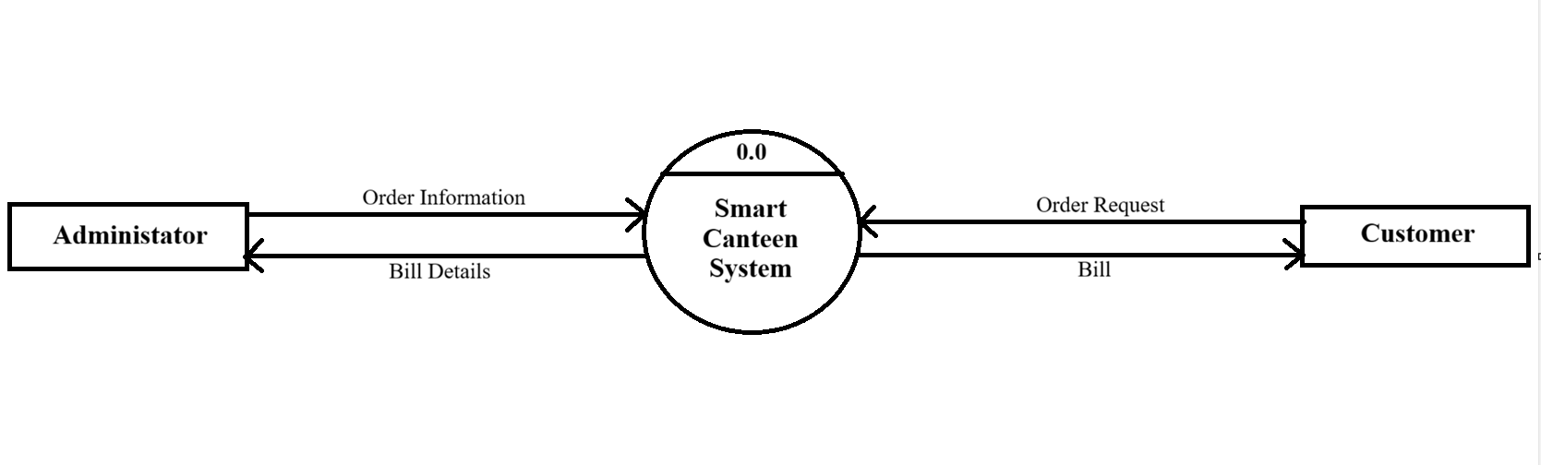

LEVEL 1 DFD
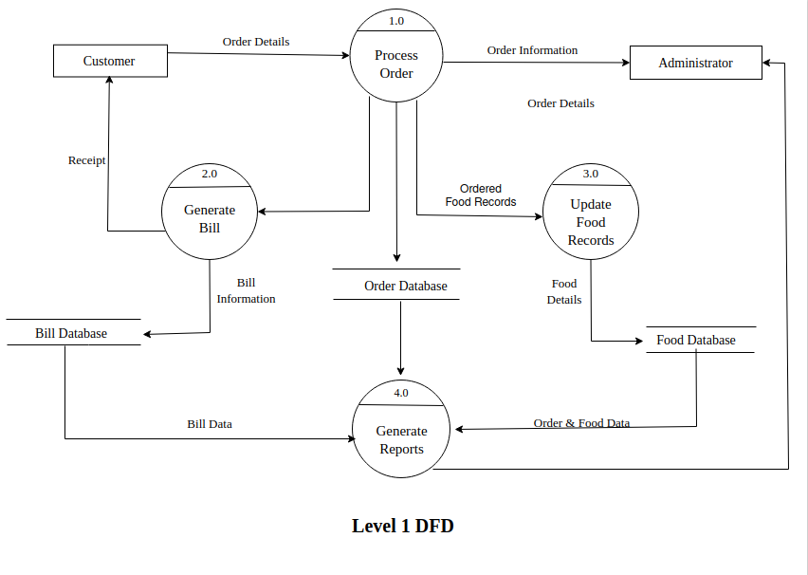
LEVEL 2 DFD
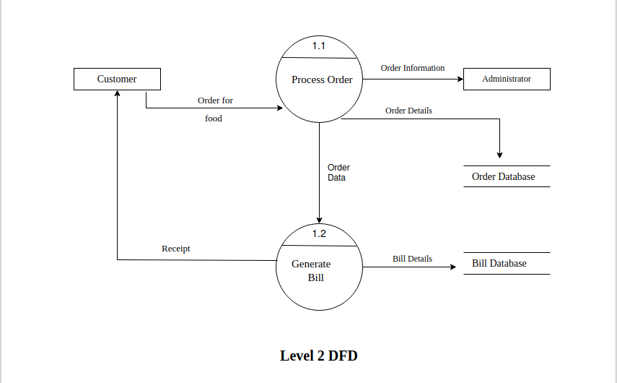

ER DIAGRAM

